
CS361 – Web Programming
Campus Events Hub
Individual Completed Work and Technical Solution
Student Name | Tariq Alanazi
Student ID | S220018465
Assigned Role | Events Page, Event Details Page, Event Data, and GET-Parameter Flow
Project | Campus Events Hub
This file contains the completed implementation corresponding to the tasks assigned to this student in the submitted project records.
1. Assigned Tasks
Week | Date | Task as Recorded
Week 1 | 15/07/2026 | Suggested the campus event categories and Saudi-based locations.
Week 2 | 22/07/2026 | Developed the initial Events page layout and sample event cards.
Week 3 | 29/07/2026 | Developed the Events page and Event Details page using a GET parameter.
Week 4 | 05/08/2026 | Tested the event ID passed between the Event Details and Registration pages.
Week 5 | 09/08/2026 | Tested the Events and Event Details pages and corrected content inconsistencies.
2. Completed Solution
- Prepared realistic event categories and Saudi-based campus or online locations.
- Built the Events page to retrieve all event records and display them in chronological order.
- Used a PHP loop to generate consistent event cards from the database.
- Created the Event Details page to validate the GET id parameter before querying the database.
- Used a prepared statement to retrieve one event securely and handled invalid or missing records.
- Connected the selected event to register.php through the event_id query parameter.
3. Event Data Prepared
Event | Category | Date | Location
Cybersecurity Awareness Workshop | Workshop | 02 Aug 2026 | SEU Riyadh Campus
Saudi Vision 2030 Seminar | Seminar | 04 Aug 2026 | SEU Riyadh Campus
Web Development Competition | Competition | 06 Aug 2026 | SEU Dammam Campus
Artificial Intelligence Career Talk | Career Talk | 09 Aug 2026 | Online – SEU Virtual Classroom
Riyadh Cultural Trip | Trip | 12 Aug 2026 | SEU Riyadh Campus departure
Entrepreneurship Skills Workshop | Workshop | 15 Aug 2026 | SEU Jeddah Campus
4. Visual Evidence
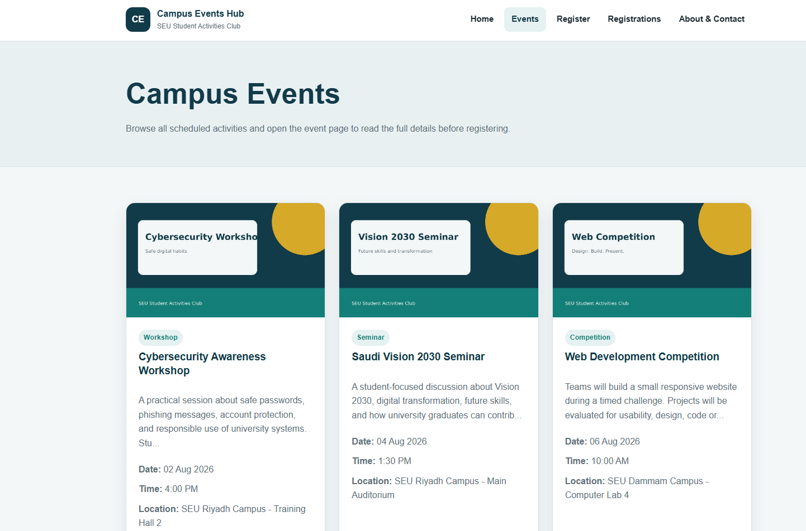
Completed Events page displaying the available campus activities.
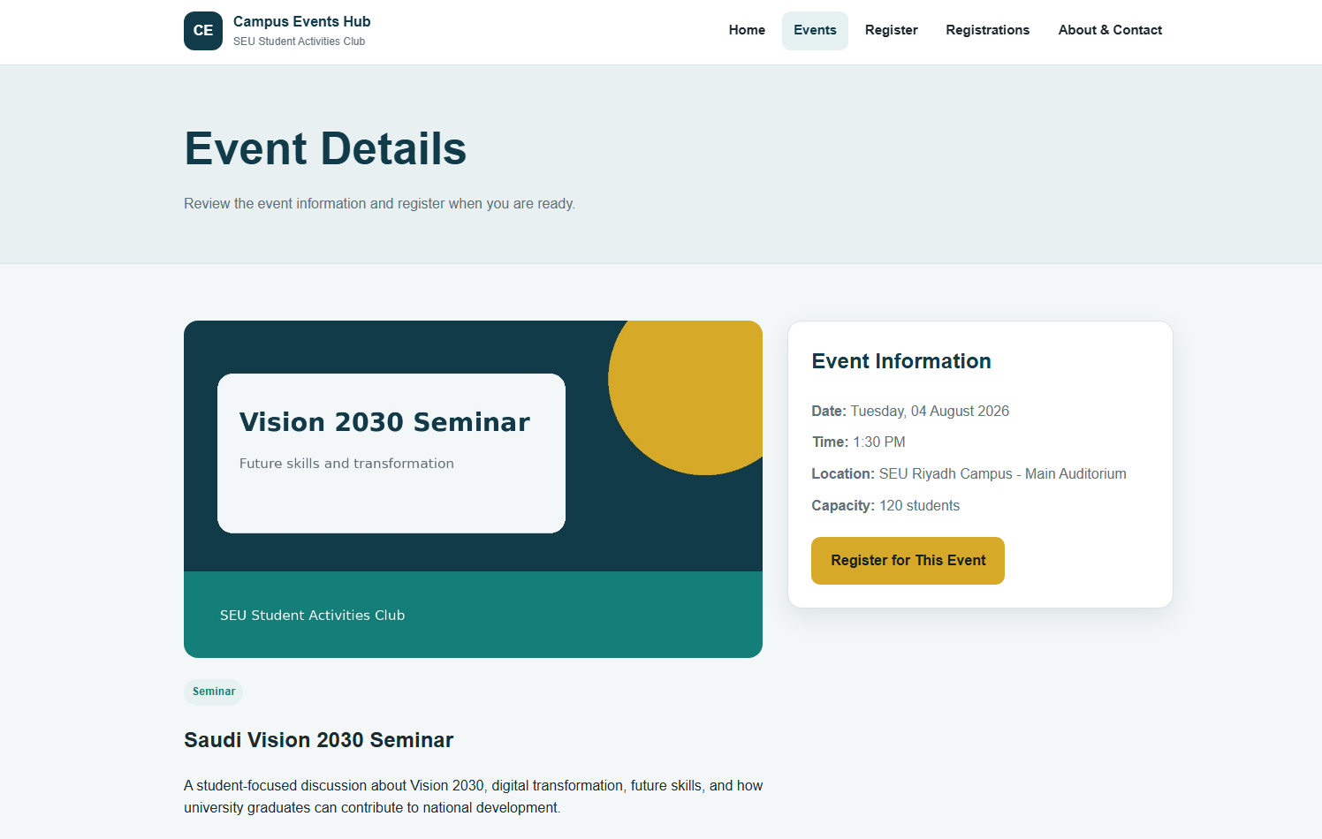
Completed Event Details page using the selected event ID.
5. Verification Results
Test | Expected / Recorded Result | Status
Open events.php | All stored events appear in ascending event date and time. | Pass
Open event.php?id=2 | The selected event information is retrieved and displayed. | Pass
Open event.php without id | An invalid-link error message appears. | Pass
Open event.php?id=999 | A selected-event-not-found message appears. | Pass
Select Register for This Event | register.php receives the matching event_id value. | Pass

6. Relevant Source-Code Solution
The following code is taken from the submitted project source files and corresponds directly to the student's assigned implementation.
events.php
<?php
require_once 'includes/db.php';
$pageTitle = 'Events';
$eventsResult = mysqli_query($conn, "SELECT * FROM events ORDER BY event_date ASC, event_time ASC");
require_once 'includes/header.php';
?>
<section class="page-banner">
<div class="container">
<h1>Campus Events</h1>
<p>Browse all scheduled activities and open the event page to read the full details before registering.</p>
</div>
</section>
<section class="section">
<div class="container">
<?php if ($eventsResult && mysqli_num_rows($eventsResult) > 0): ?>
<div class="event-grid">
<?php while ($event = mysqli_fetch_assoc($eventsResult)): ?>
<article class="event-card">
<img src="<?php echo htmlspecialchars($event['image']); ?>" alt="<?php echo htmlspecialchars($event['title']); ?>">
<div class="event-card-content">
<span class="badge"><?php echo htmlspecialchars($event['category']); ?></span>
<h3><?php echo htmlspecialchars($event['title']); ?></h3>
<p><?php echo htmlspecialchars(mb_strimwidth($event['description'], 0, 130, '...')); ?></p>
<ul class="meta-list">
<li><strong>Date:</strong> <?php echo date('d M Y', strtotime($event['event_date'])); ?></li>
<li><strong>Time:</strong> <?php echo date('g:i A', strtotime($event['event_time'])); ?></li>
<li><strong>Location:</strong> <?php echo htmlspecialchars($event['location']); ?></li>
</ul>
<a class="button button-outline" href="event.php?id=<?php echo (int) $event['id']; ?>">View Details</a>
</div>
</article>
<?php endwhile; ?>
</div>
<?php else: ?>
<div class="empty-state">
<h2>No events found</h2>
<p>The events list is currently empty.</p>
</div>
<?php endif; ?>
</div>
</section>
<?php require_once 'includes/footer.php'; ?>

event.php
<?php
require_once 'includes/db.php';
$pageTitle = 'Event Details';
$event = null;
$errorMessage = '';
if (!isset($_GET['id']) || !ctype_digit($_GET['id']) || (int) $_GET['id'] < 1) {
$errorMessage = 'The event link is invalid. Please choose an event from the events page.';
} else {
$eventId = (int) $_GET['id'];
$stmt = mysqli_prepare($conn, 'SELECT * FROM events WHERE id = ?');
mysqli_stmt_bind_param($stmt, 'i', $eventId);
mysqli_stmt_execute($stmt);
$result = mysqli_stmt_get_result($stmt);
$event = mysqli_fetch_assoc($result);
mysqli_stmt_close($stmt);
if (!$event) {
$errorMessage = 'The selected event could not be found.';
} else {
$pageTitle = $event['title'];
}
}
require_once 'includes/header.php';
?>
<section class="page-banner">
<div class="container">
<h1>Event Details</h1>
<p>Review the event information and register when you are ready.</p>
</div>
</section>
<section class="section">
<div class="container">
<?php if ($errorMessage): ?>
<div class="message message-error">
<?php echo htmlspecialchars($errorMessage); ?>
</div>
<a class="button" href="events.php">Return to Events</a>
<?php else: ?>
<div class="detail-layout">
<article>
<img class="detail-image" src="<?php echo htmlspecialchars($event['image']); ?>" alt="<?php echo htmlspecialchars($event['title']); ?>">
<span class="badge"><?php echo htmlspecialchars($event['category']); ?></span>
<h2><?php echo htmlspecialchars($event['title']); ?></h2>
<p><?php echo nl2br(htmlspecialchars($event['description'])); ?></p>
</article>
<aside class="detail-card">
<h2>Event Information</h2>
<ul class="meta-list">
<li><strong>Date:</strong> <?php echo date('l, d F Y', strtotime($event['event_date'])); ?></li>
<li><strong>Time:</strong> <?php echo date('g:i A', strtotime($event['event_time'])); ?></li>
<li><strong>Location:</strong> <?php echo htmlspecialchars($event['location']); ?></li>
<li><strong>Capacity:</strong> <?php echo (int) $event['capacity']; ?> students</li>
</ul>
<a class="button button-accent" href="register.php?event_id=<?php echo (int) $event['id']; ?>">Register for This Event</a>
</aside>
</div>
<?php endif; ?>
</div>
</section>
<?php require_once 'includes/footer.php'; ?>

